**Ideation Phase**

**Brainstorm & Idea Prioritization**

|  |  |
| --- | --- |
| Date | 19 September 2022 |
| Team ID | PNT2022TMID50136 |
| Project Name | Statistical Machine Learning Approaches to Liver Disease Prediction |
| Maximum Marks | 4 Marks |

**Brainstorm & Idea Prioritization**

Reference: https://app.mural.co/t/statisticalapproachestoliver1458/m/statisticalapproachestoliver1458/1664697924856/e6c5448454593bbfa2463481d4a039f7d60edce2?sender=u0f9c95c32700d2cad4571344

**Step-1: Team Gathering, Collaboration and Select the Problem Statement**

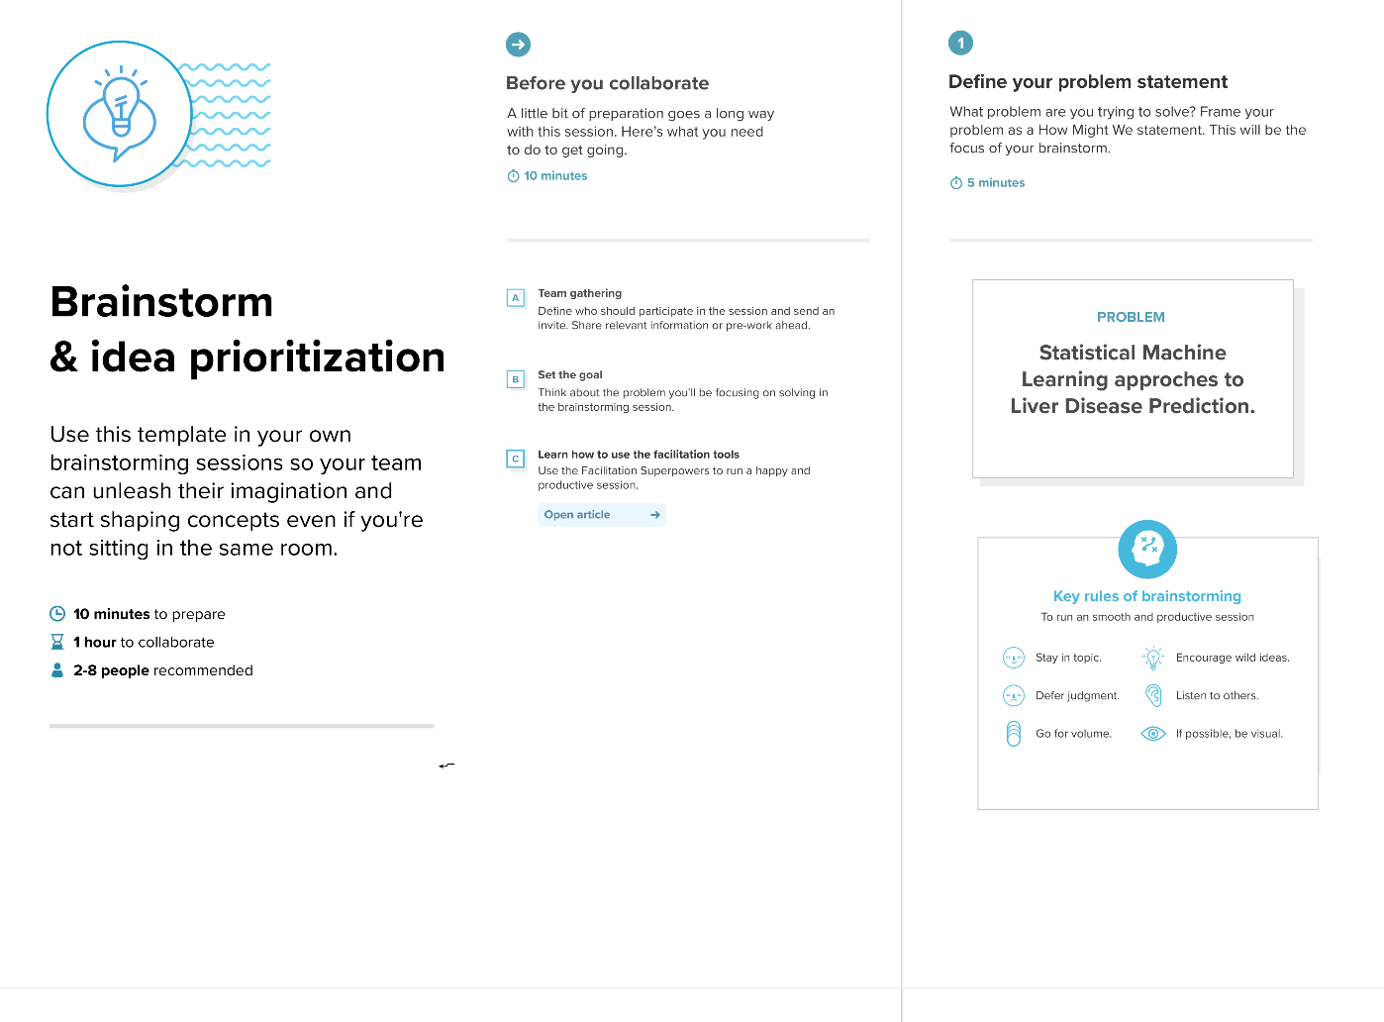

**Step-2: Brainstorm, Idea Listing and Grouping**

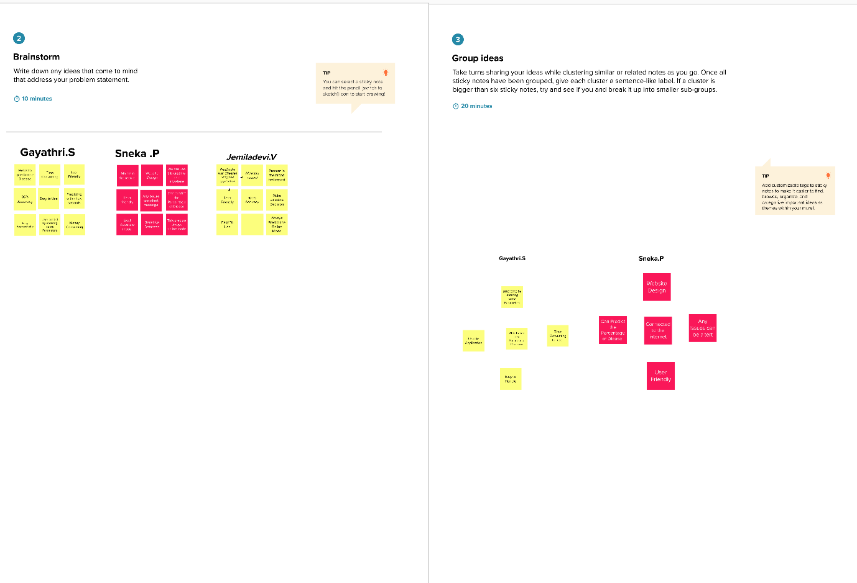

**Step-3: Idea Prioritization**

